Excel Assignment - 18

1. What are comments and what is the importance if commenting in any code?

Answer : A comment is a programmer-readable explanation or annotation in the source code of a computer program. They are added with the purpose of making the source code easier for humans to understand, and are generally ignored by compilers and interpreters.

---------------------------------------------------------------------------------------------------------------------------------------

1. What is Call Statement and when do you use this statement?

Answer : Transfers control to a Sub procedure, Function procedure, or dynamic-link library (DLL) procedure

This statement calls another application. This statement has the following syntax: call subsystem ([parametername = value. {, parametername = value}]); The call statement specifies optional parameters that call another application.

---------------------------------------------------------------------------------------------------------------------------------------

3. How do you compile a code in VBA? What are some of the problem that you might face when you don’t compile a code?

Answer:

1. Open your workbook in Excel.
2. Press Alt + F11 to open Visual Basic Editor (VBE).
3. Right-click on your workbook name in the "Project-VBAProject" pane (at the top left corner of the editor window) and select Insert -> Module from the context menu.
4. Copy the VBA code (from a web-page etc.)

VBA compile errors will prevent affected routines from running

---------------------------------------------------------------------------------------------------------------------------------------

1. What are hot keys in VBA? How can you create your own hot keys?

Answer :

|  |  |  |
| --- | --- | --- |
| **Shortcut** | **Windows** | **Mac** |
| Jump between Excel and the VB Editor Window | Alt+F11 | Opt+F11 or Fn+Opt+F11 |
| Run Macro/Procedure | F5 | F5 |
| Step Through Each Line of Code | F8 | Cmd+Shift+i |
| Run to Cursor | Ctrl+F8 |  |
| Add a Break Point | F9 |  |
| Reset/stop code | Alt,R,R |  |
| Compile VBA Project | Alt,D,L |  |

**To assign a keyboard shortcut do the following:**

 Begin keyboard shortcuts with CTRL or a function key. Press the TAB key repeatedly until the cursor is in the Press new shortcut key box. Press the combination of keys that you want to assign.

--------------------------------------------------------------------------------------------------------------------------------------

1. Create a macro and shortcut key to find the square root of the following numbers 665, 89, 72, 86, 48, 32, 569, 7521

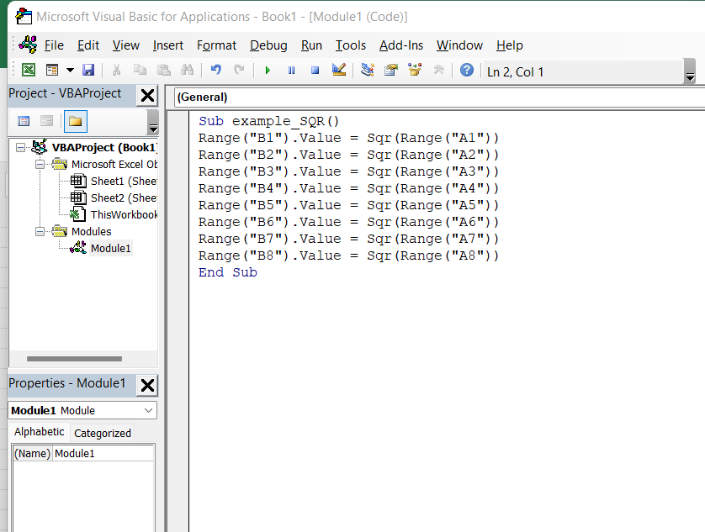

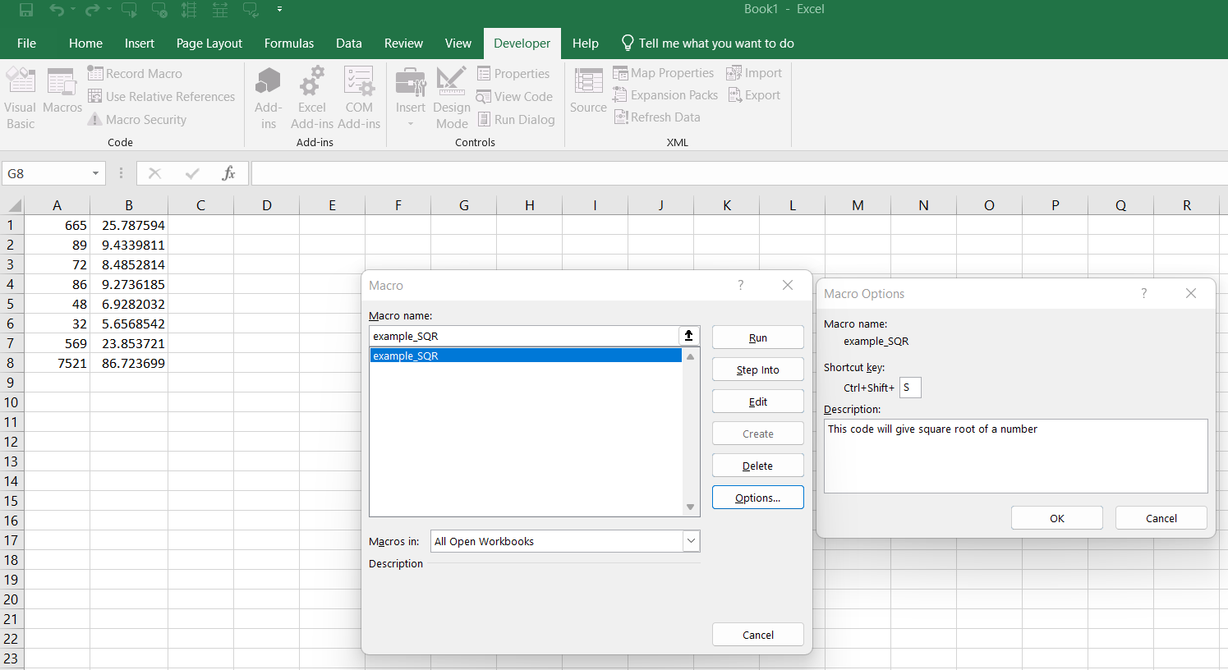

--------------------------------------------------------------------------------------------------------------------------------------

6. What are the shortcut keys used to

a. Run the code : Run Current Procedure (F5)

b. Step into the code :  **Shift+F8**

c. Step out of code : **Ctrl+Shift+F8**.

d. Reset the code : Alt,R,R